Application WorkFlow Screenshots:

Step1:Go to the login page and use the below user credentails to login.

Email address: admin@gmail.com
Password: Admin@123

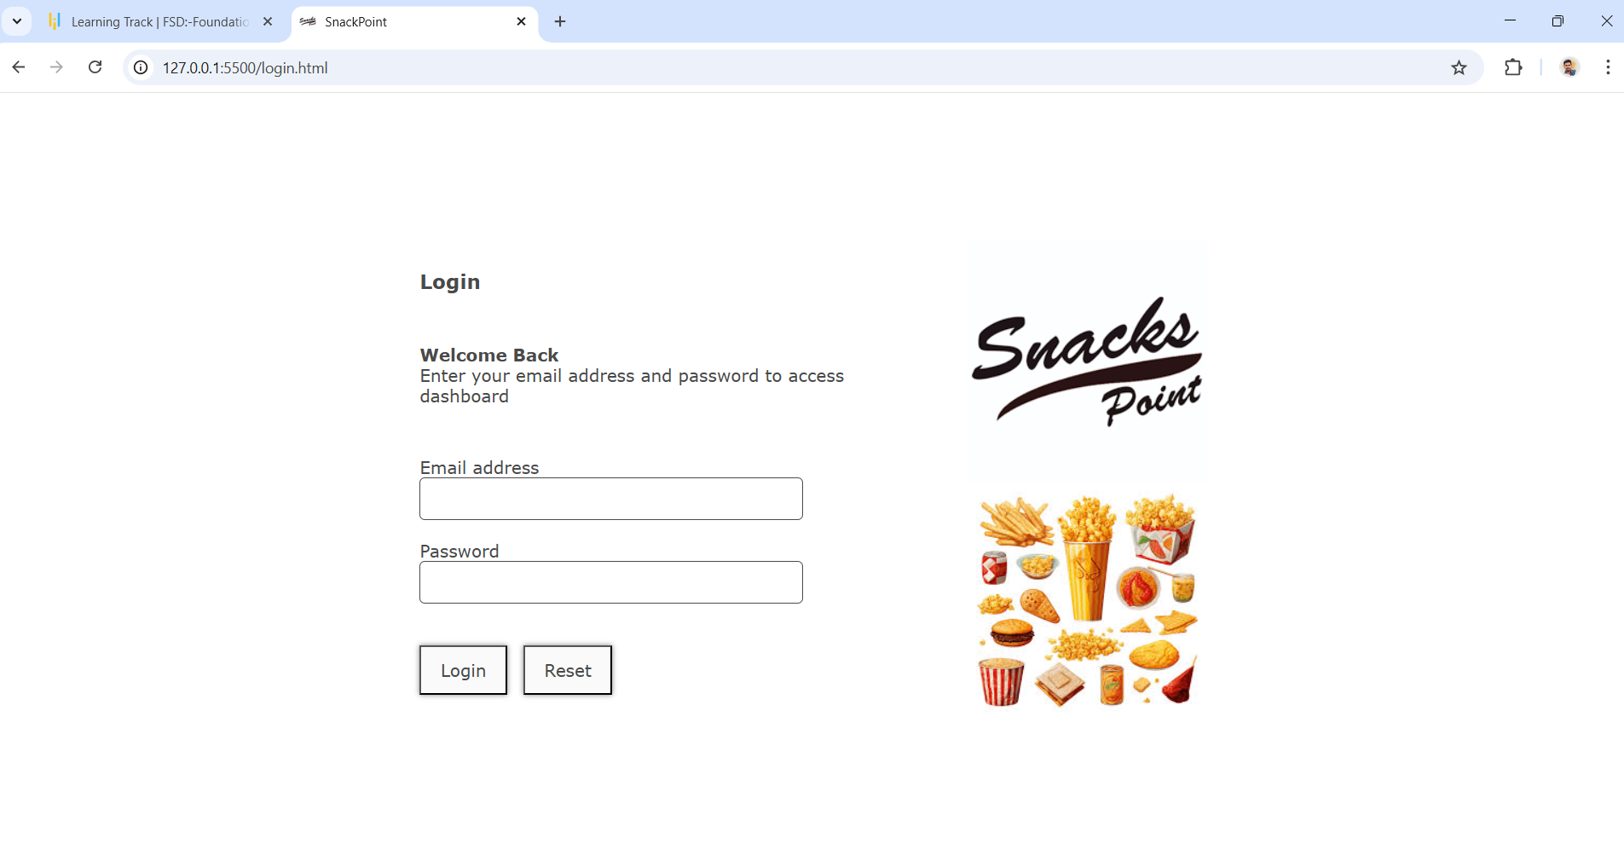

Step2: Once after login, You will be seeing the dashboard of snackpoint application with listed restuarants.
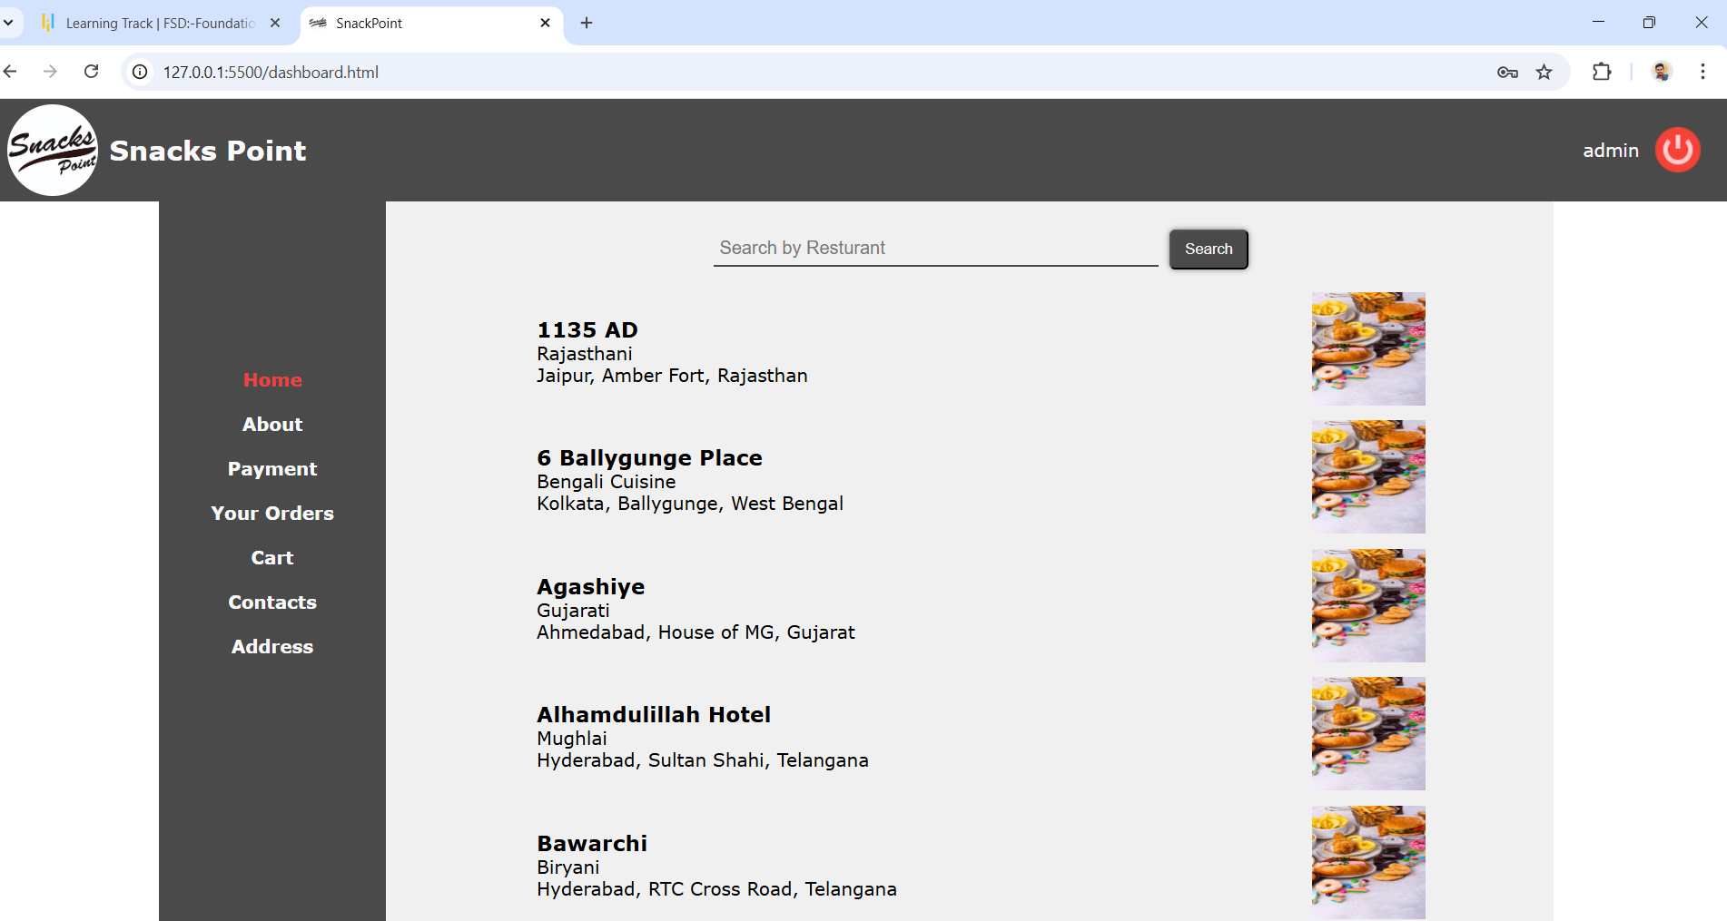

Step3:By clicking on the restaurant name or image of restaurant, you will be redirecting to the items list of specific restaurant.
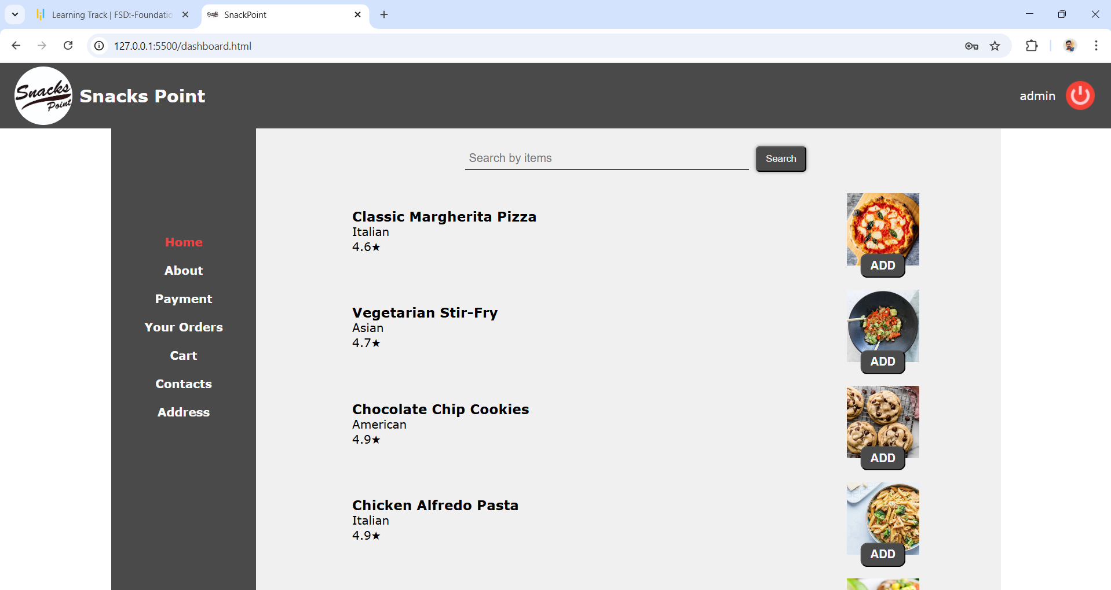

Step4:In the above screenshot, you can see the ADD button, By clicking on that, item will be selected and moved to the cart.

You can select more then one item in the list.
After selecting the items, then click on the cart in the menu to move to cart.
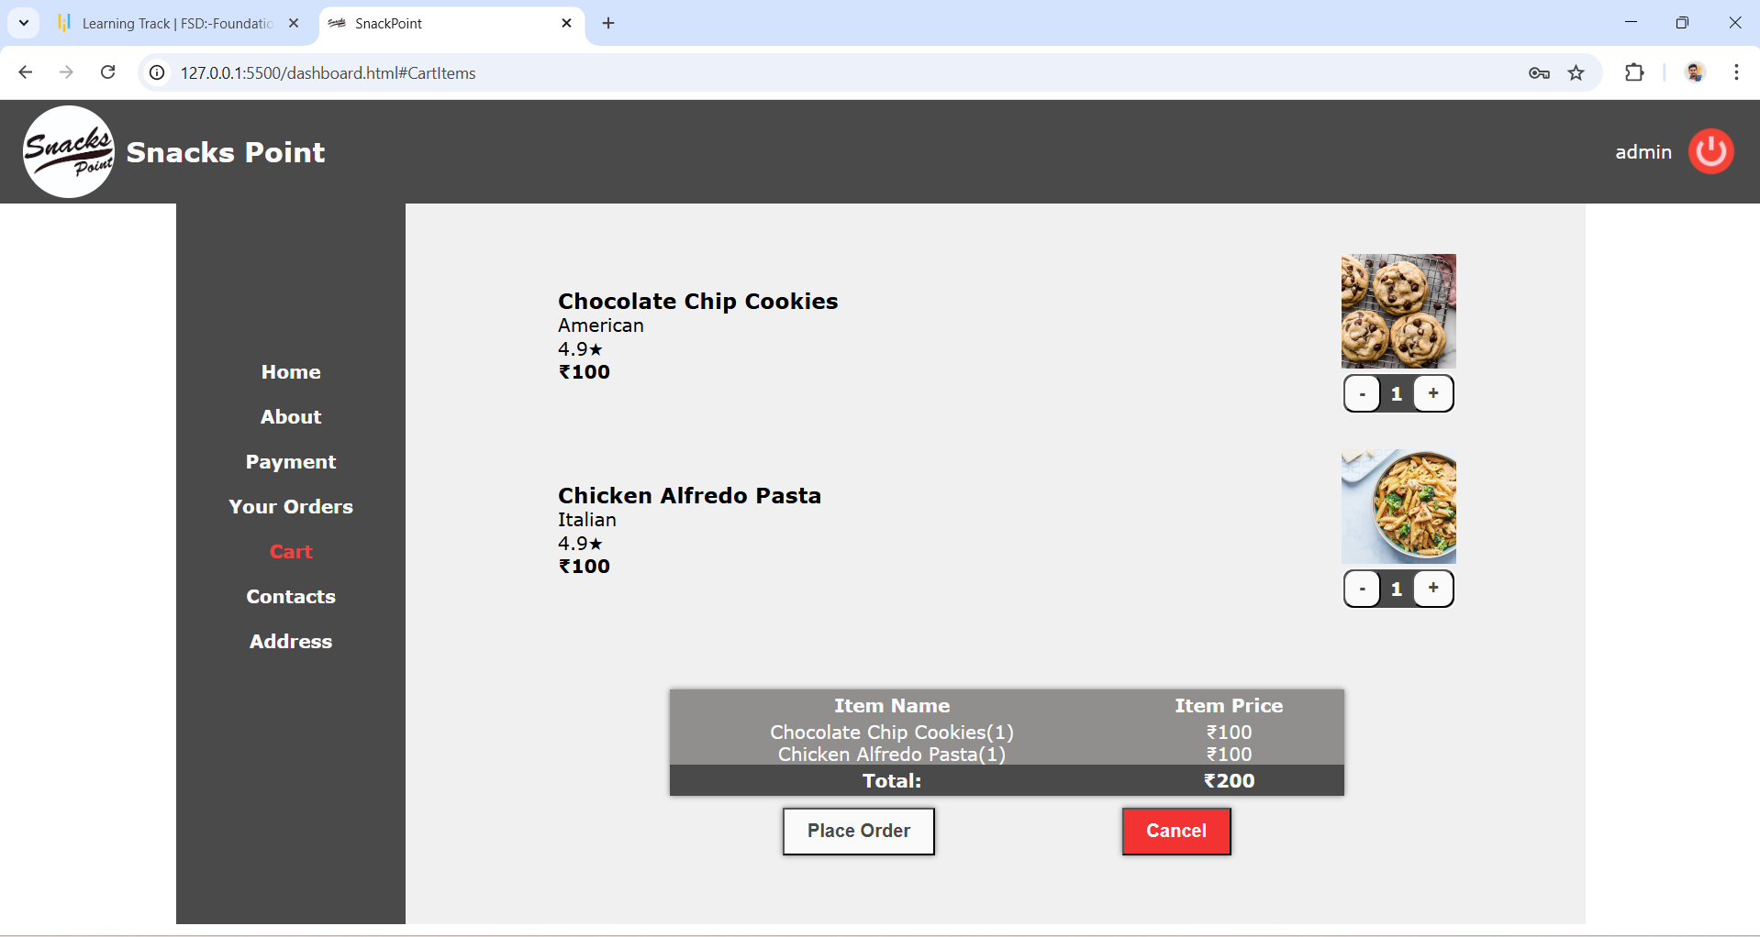

Step5: In the above screenshot, you can increase or decrease the quantity of item by clicking on the Plus or Minus button.
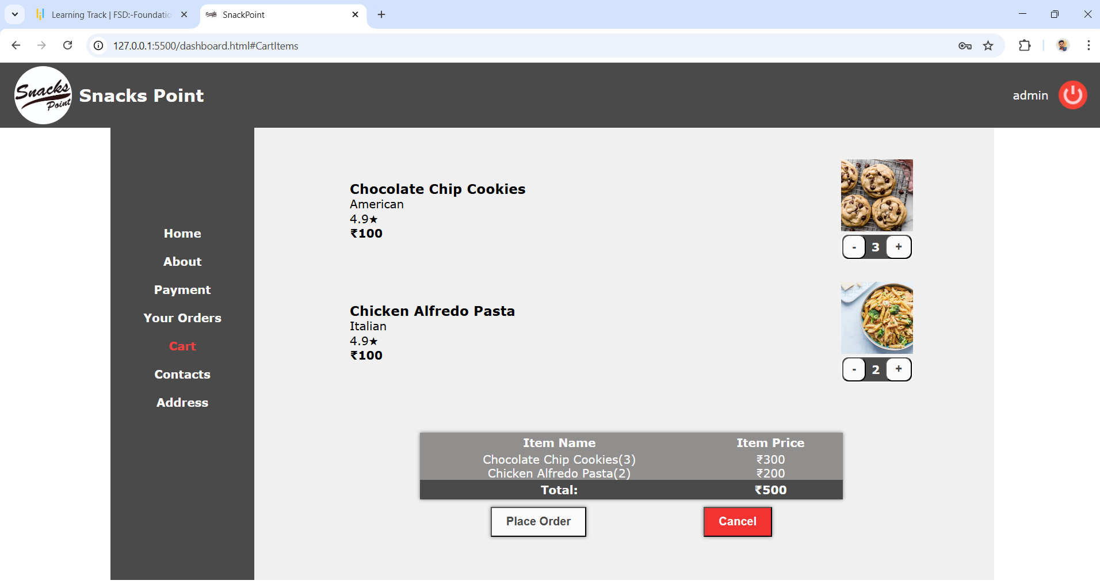
So automatically, billing details on the table also get updated, as you can see in the above screenshot.

Step6:If you want cancel the order, you can click on the cancel button, so that it will redirect to home/dashboard again.

Step7: If want place the order, then click on the Place Order button on the below screenshot, So that it will be moved for the payment section.

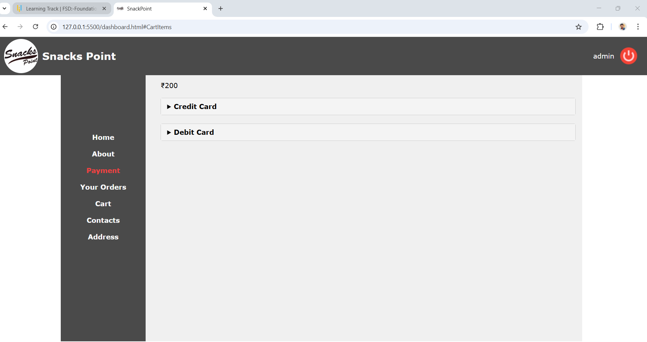

Step8: In the payment section, you can see the list of payment methods, then choose the any one of it and make the payment.
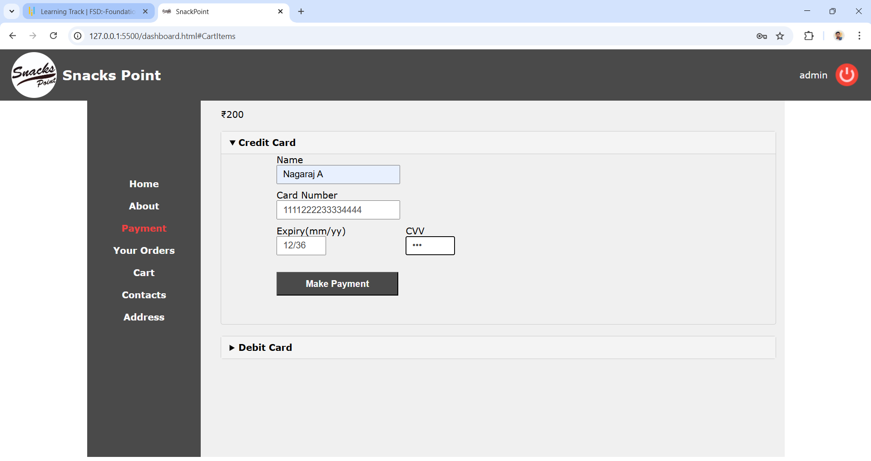

Step9: Once after the payment, you will be seeing the successfull message and post that,page will be redirecting to orders list.
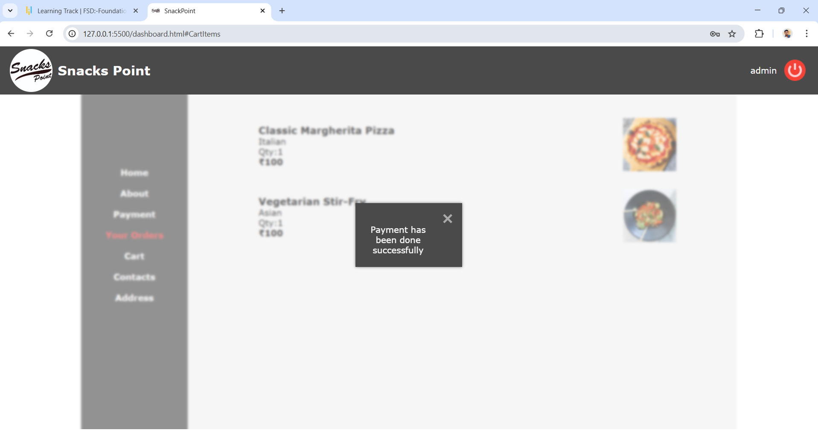

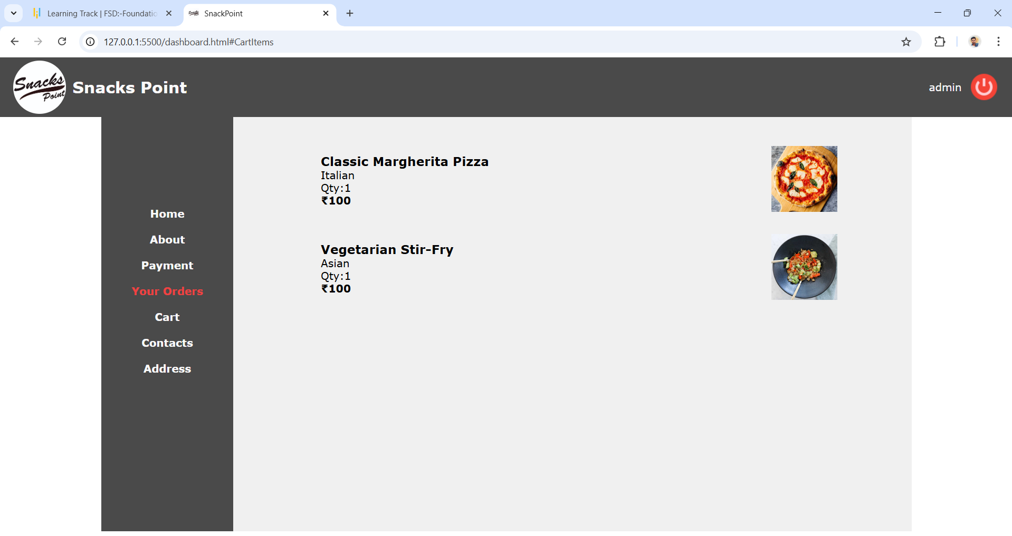

Step10: You can see about the application in the About page.
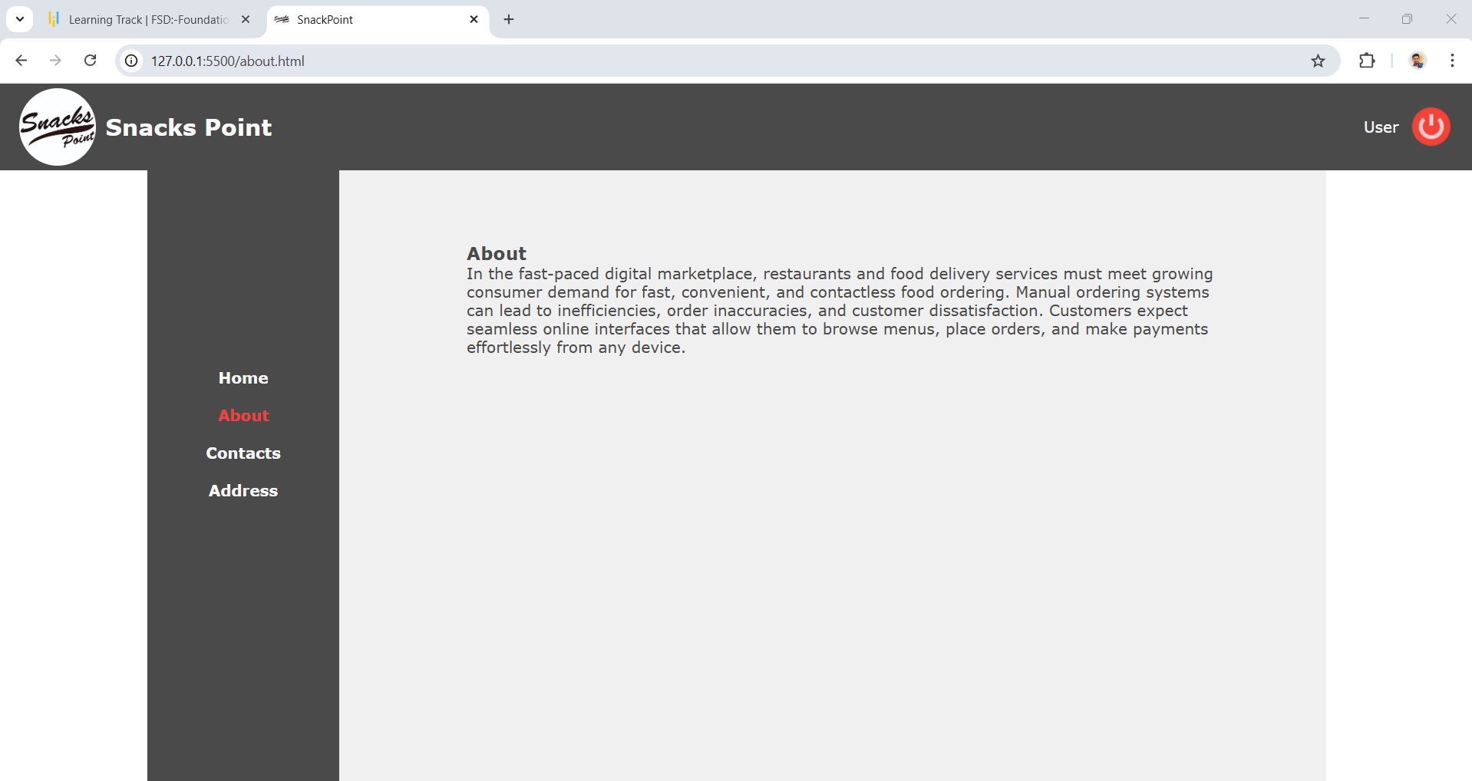

Step11: You can see the contacts in the Contacts page.
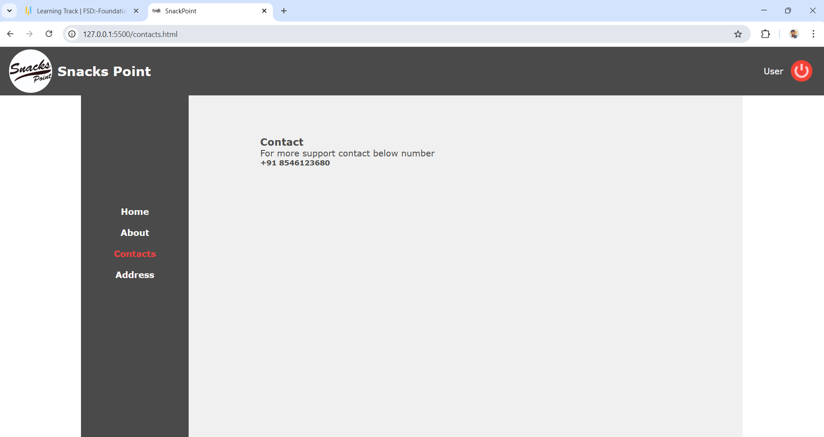

Step12: You can see the address details in the Address page.
